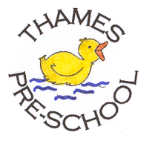
Health and Safety Procedures
Animals and pets brought in by visitors

- Before an animal/pet is brought into the setting, the staff will check the registration documentation of each child attending for that session to check for allergies, phobias and also parental permissions.
- The owner of the animal/creature maintains responsibility for it in the setting.
- The owner carries out a risk assessment detailing how the animal/creature is to be handled and how any safety or hygiene issues will be addressed.
- No dogs on the Government’s Banned Dogs list are to be brought on site at any time. All other dogs brought on site by parents/carers during arrival and departure times must be on a lead and under control. The Pre-school Leader reserves the right to request that a dog is not brought on site, if the animal is out of control, or likely to pose a risk.
- If staff are concerned that a family owns a dog which is on the ‘banned dog’ list, it is treated as a safeguarding concern and it is reported to the relevant authority and safeguarding procedures are followed.

This procedure is adopted by Thames Pre-school Committee

Further guidance
https://www.gov.uk/control-dog-public/banned-dogs

