Concern Form Part A
- Part A is to be completed by the adult who first has a concern and reported to the Designated Safeguarding Lead (DSL) without delay.
Separate concern forms should be completed for both alleged instigator(s) and victim(s) of incidents.
- Part B is to be completed by the DSL

Child’s name
Date of birth
This may be added by the DSL having ensured there is no risk of confusion if children have similar names
Name of member of staff/person reporting the concern |  | PLEASE PRINT
 |  | Signature
Role
Date DD/MM/YYYY |  |  | Time

Concern(s) - Use the body- map show any marks or injuries.
Additional form used? | Yes / No | Page of

Concern Form Part B
To be completed by the Designated Safeguarding Lead (D/DSL)

Name of D/DSL reviewing the concern
Safeguarding support already in place
Tick and add name where known at time of report
None | ESA or Support Assessment |  |  | Child in Need | Child Protection Plan |  | Looked After |  | Previous social care involvement
Name and role of allocated worker
Data analysis:  if the concern relates to child on child abuse, state which: | This includes any reports and concerns, including those outside the school and online:  - bullying (including cyberbullying, prejudice-based and discriminatory bullying)  - abuse in intimate personal relationships between peers  - physical abuse  - sexual violence |  |  |  |  | - sexual harassment  - causing someone to engage in sexual activity without consent  - consensual and non-consensual sharing of nudes and semi nudes images and or videos  - upskirting  - initiation/hazing type violence and rituals
Name of person taking actions |  | Actions/next steps  Please detail conversation and rationale for decisions – include whether concerns were shared with parents/carers, MASH and if not outline reasons why. |  |  |  |  |  | Date of action

What would the child like to happen next?
Has the child’s wishes been considered when deciding action to be taken? | Yes | No
If no, please indicate why not

A summary of actions must be shared with the person who raised the concern
Summary of action discussion - please include any ‘gut feeling elements’ in the discussion and also the potential impact on the child. |  |  | Date
If actions agreed
Signature of person (overleaf) who raised the concern
If actions not agreed  A file note added to the child’s file with a summary of discussion and the outcome/s.  Signature of person who raised the concern overleaf |  | File note document number

Body Map
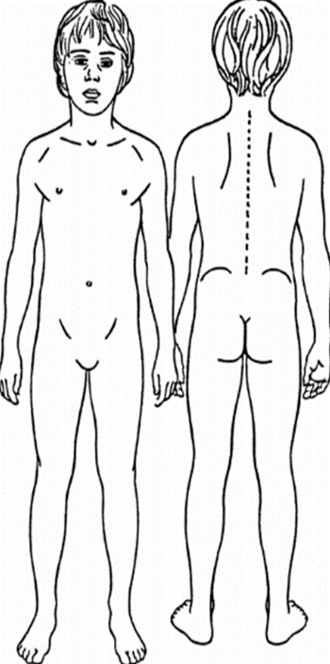
Children must not be undressed or photographs taken of any marks or injuries

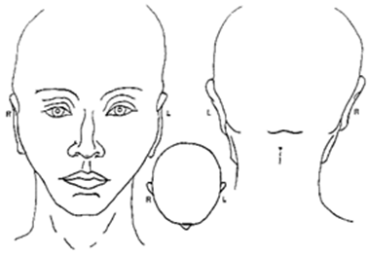
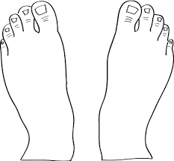
Back
Palm

