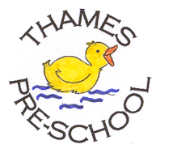
Health and Safety Procedures
Control of Substances Hazardous to Health (COSHH)
- Staff at Thames Pre-school implement the current guidelines of the Control of Substances Hazardous to Health (COSHH) Regulations.
- Personal protective equipment (PPE), such as nitrile gloves, vinyl gloves, aprons etc., is available to all staff as needed and stocks are regularly replenished.
- Hazardous substances are stored safely away from the children.
- Chemicals used in the setting should be kept to the minimum to ensure health and hygiene is maintained.
- Environmental factors are considered when purchasing, using and disposing of chemicals.
- All members of staff are vigilant and use chemicals safely.
- All COSHH sheets are available to staff in the relevant areas of the building. A full list of where each sheet can be found is located on the notice board in the office.
- Anti-bacterial hand wash for children is not normally used, unless specifically advised during an infection outbreak, such as Pandemic flu or Coronavirus.
- Anti-bacterial cleaning agents are restricted to toilets, nappy changing areas and food preparation areas and staff are careful when spraying down the tablecloths when children are nearby.
- Members of staff wear suitable rubber or nitrile gloves when using cleaning chemicals.

This procedure is adopted by Thames Pre-school Committee

